[PRESS RELEASE_202312]

**Millennial and GenZ male travelers are on the rise and contactless travel is here to stay**

**ConsumerInsight X Tidesquare**

**predicts 2024 travel trends for outbound Korean travelers**

* Millennial and GenZ male travelers to become a key demographic
* Contactless travel continues to be high priority as travelers prioritize safety and relaxation
* Narrower travel destination choices due to global unrest and high fuel prices
* Increased role of exchange rate and prices on destination selections
* Continued development of products and promotions to meet these trends

**\*Source**

* ConsumerInsight “Tracking Koreans’ Travel Behavior Changes 2017-2023” (Presented at ‘Wit Seoul 2023’ on Nov. 2, 2023)
* Tidesquare (Tourvis, Kyte) 2023.01 – 2024.03 booking data

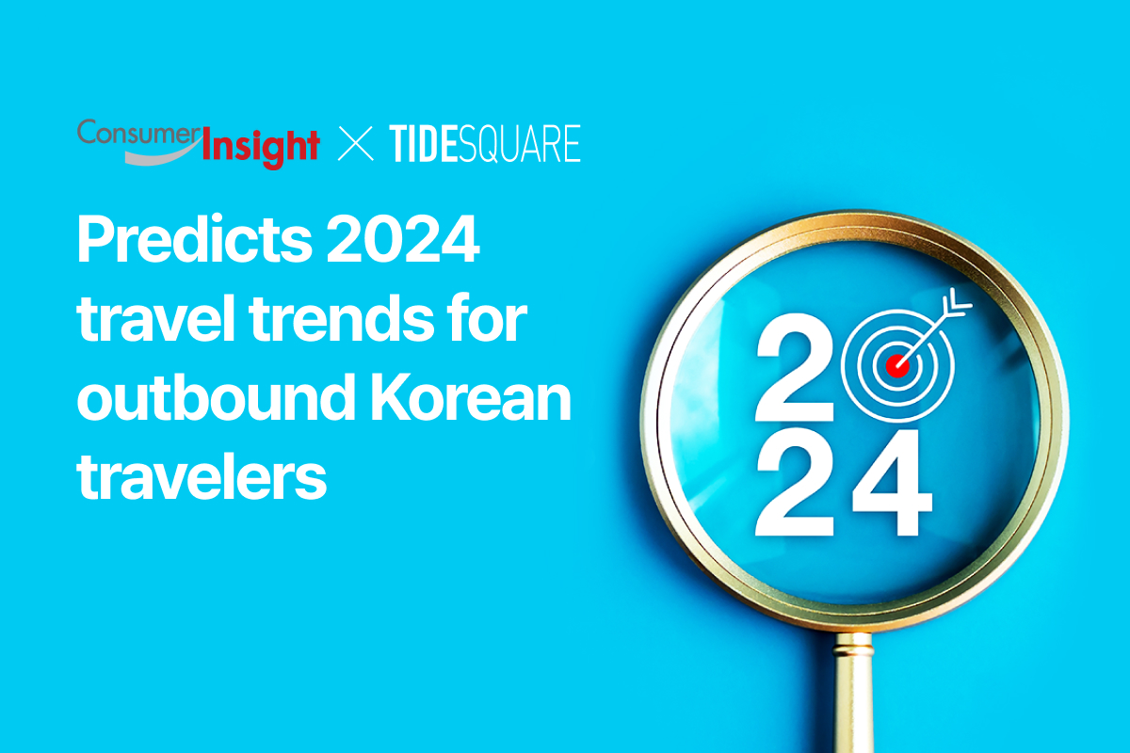

Travel technology company TIDESQUARE has forecasted Korean outbound travel trends for 2024 based on 2023-2024 booking trends and data from research firm ConsumerInsight.

Based on data presented by ConsumerInsight at ‘WiT Seoul 2023’ on Nov. 2, 2023 and internal booking trends, TIDESQUARE analyzed traveler behavior and purchase journeys to predict major changes from the pre-COVID 19 era, including the continuation of contactless travel, narrow scope of travel destinations due to global unrest and high oil prices as well as stronger mobility services.

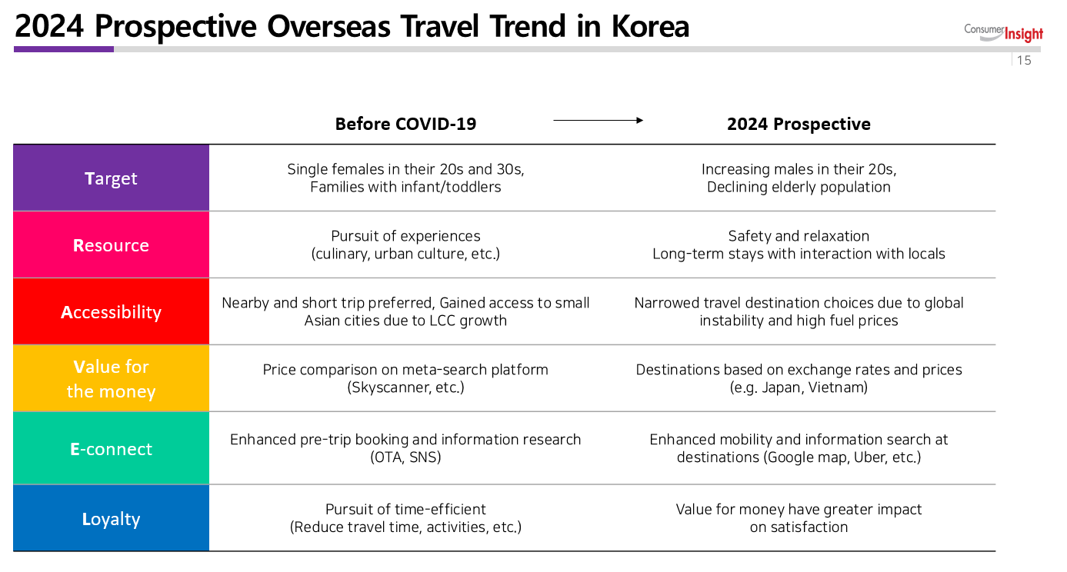

**Predicting a rise in small-town travel destinations**

According to ConsumerInsights' analysis of T.R.A.V.E.L. - the six key factors that shape traveler behavior and attitudes - the most significant change in the “Target” audience in 2024 will be men in their 20s. There will also be some shifts in travel patterns as single women in their 20s and 30s and families with infants and toddlers, who were key pre-COVID-19 travelers, become less common and the older population declines.

“Resource” predicts that the "contactless" travel trends that have been established during the pandemic will continue for the foreseeable future, with people seeking safety and relaxation. Tidesquare data shows that while major cities with popular tours and experiences have consistently been the most popular destinations, since the second half of 2023 bookings for small towns and lesser known destinations have increased. In Japan, small town hotel bookings accounted for more than 22% of all hotel bookings in the country, with winter hot spring destinations also increasing, not only in the more popular hot spring areas such as Yufuin, Haneda, Jozankei and Noboribetsu, but also lesser known hot spring areas such as Arima, Gero and Kurokawa. In Vietnam, the proportion of accommodation bookings in smaller cities other than Da Nang and Hanoi more than doubled year-on-year, demonstrating a new direction in contactless travel.

**Strong growth in short-haul destinations with strong impact of exchange rates**

In terms of “Accessibility”, international travel will continue to grow as COVID-19 becomes an endemic in most destinations , but in 2024, global unrest and high fuel prices will narrow the choice of destinations. In 2023, the most popular overseas air routes were Tokyo (13.77%), Osaka (11.89%), Fukuoka (10.64%), Da Nang (3.25%), and Bangkok (2.88%), and the top five were all in East Asia, with the commonality being short-haul destinations of around 5 hours. Booking trends for Q1 2024 are expected to be similar to those for Q1 2023, with short-haul destinations around 5 hours continuing to be strong for the foreseeable future.

“Value for money” as a criteria in selecting destinations is going to increase in importance. While in the past, travel plans were made by comparing ticket prices on metasearch platforms such as Skyscanner and Naver, next year they are expected to be influenced by other factors such as exchange rates and local prices. In the case of Japan, with its close proximity as well as fall of Japanese yen against Korean won (100 yen : 800 KRW in November 2023), flights to Japan accounted for 30% of airline ticket bookings this year and into the first quarter of next year.

**Increased use of mobility services and luxury goods**

Along with changes in travel trends, changes in “E-connect” (information channels) are also expected. While OTAs and SNS will remain influential in pre-trip bookings and information searches, the number of people looking for information in destination will increase, and mobility services such as Google Maps, Uber, and KakaoT, which allow users to check travel routes and book taxis, electric bicycles, and kickboards, will be widely used.

“Loyalty” seems to be the at the core of the shift in consumer spending. As the standard of satisfaction focuses more on recreation and healing, the tendency to pursue “value-for-money” travel, which emphasizes efficient use of time is likely to increase rather than “value-for-money” travel focusing unconditionally on cost-saving. As a result, demand for products that prioritize safety and private packages such as VIP tours and luxury hotels is expected to increase.

With the declaration of COVID-19 being an endemic in May 2023, Korean outbound travel sentiment rebounded once again and 2024 will be a time to take a leap forward with travel trends that have changed before and after COVID-19.

Min Yoon, CEO of TIDESQUARE stated “Travel trends change every year and it is the travel platform’s differentiated technology and diverse services that will keep them competitive. We plan to continue to meet the needs of our consumers through our online travel platform Tourvis, content-rich air and hotel reservation service Kyte and real time special price notification app Playwings.”

================================================================

* **CONSUMERINSIGHT** **(**[**www.consumerinsight.co.kr**](http://www.consumerinsight.co.kr)**)**

ConsumerInsight offers specialized and scientifically rigorous research services across diverse industries, including automotive, telecommunications, retail, tourism, and finance, leveraging an efficient online panel tailored for non-face-to-face surveys. Our emphasis is on elevating the value of data by seamlessly integrating various big data sources with panel research, and we are dedicated to applying these insights across multiple sectors. Notably, we have recently introduced 'KD Panel,' a survey platform with nationwide representation, exclusively operating on a 100% mobile basis. This platform is now open for use by professionals throughout the research industry.

**\*TIDESQUARE** ([www.tidesquare.com](http://www.tidesquare.com))

TIDESQUARE is South Korea’s leading technology focused travel agency and operator of OTA brand “Tourvis” and #1 premium OTA brand “Privia Travel”. Established in 2009, TIDESQUARE is a top 3 BSP travel agent (Nov. 2022 BSP ranking) with a strong network of global and local partnerships with industry-leading platform operators including Kakao Mobility, SK Telecom and Naver. TIDESQUARE stands at the forefront of the South Korean travel landscape leading NDC and direct airline connectivity as the first Korean agency to obtain NDC certification.